

Suggested answers only



**You entered the ‘Stories of Survival’ short story competition. The theme of this year’s competition is ‘Nature: friend or enemy?’**

**Write a story about a hiker who gets caught in a storm while hiking in the mountains.**

*Writing topic taken from Paper 2 of the 2022 HKDSE English Language Examination ©HKEAA*

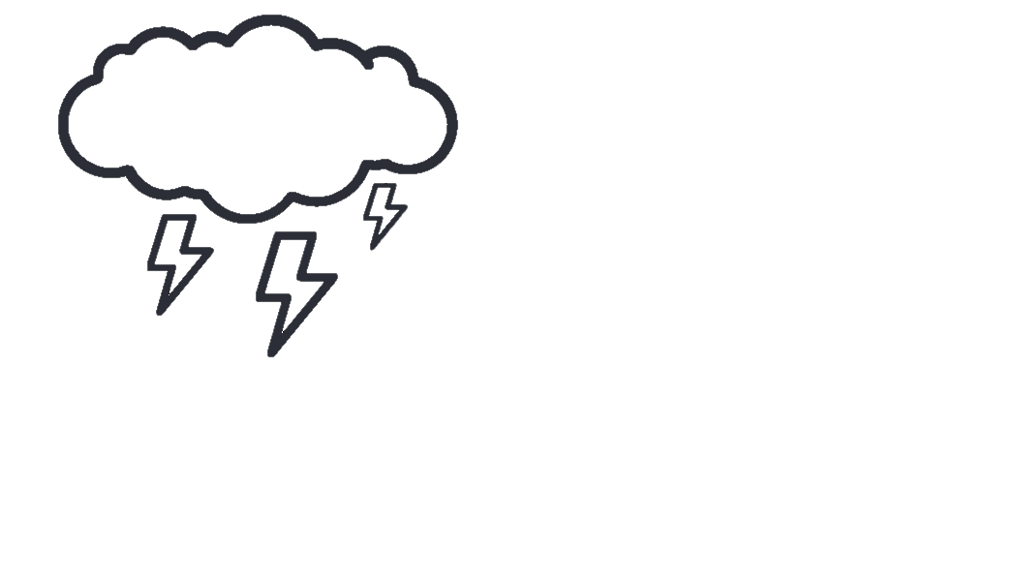

**This is not simply a survival story. The theme “Nature: friend or enemy?” should also be addressed.**

**Topic**

**Story Idea Words**

**Start your story using one of the following strategies.**



**Character Description**

“Man is born to conquer nature and not to follow it” was a saying that best described how I used to live my life. As an ardent fan of hiking, I loved to push hiking to the limits to challenge myself. With rugged steep slopes and slippery rocks, the Sharp Peak was considered the most dangerous hiking trail in town, which always topped my hiking list.



**Setting Description**

Last Saturday, Ian and I set off for the Sharp Peak, a notoriously challenging hiking trail in town. The trail began with a narrow sandy ridge with sharp drop-offs. It was also known as “The Maze” because it was full of dead-ends and prone to flash floods and dangerous rock falls. The weather couldn’t have been better when our adventure started. However, in a split second, it changed completely. A sense of unease soon overtook us.



**Dialogue**

“Hey, are you getting cold feet? Fine, let’s go our own ways,” I blurted to Ian. The sky was blackened with thick clouds and I could smell rain in the air – bring it on! Ian was such a coward. He decided to turn back but I would definitely continue the hike alone.

**Describing the Setting**

* spectacular/breathtaking view
* slippery rocks/mossy stones
* rough/rugged steep slopes
* a narrow sandy ridge with sharp drop-offs
* full of dead-ends
* prone to flash floods and dangerous rock falls
* the sky was blackened with thick clouds
* rain poured
* thunders cracked/crashed/  
  boomed/rumbled
* gales howled/whipped bitterly
* lightning struck/flashed/ flickered across the sky

5 Falling Action &

6 Resolution

* How did the story end?
* What did the character(s) learn from this incident?

Ian called the police and rescuers found me. I was sent to hospital by a helicopter. I realised I should have treated nature with more respect.

1 Exposition

* Who is/are the character(s)?
* What is the setting of the story?

On a Saturday, Ian and I went hiking in the Sharp Peak, the most dangerous hiking trail in town.

4 Climax

* What is the most exciting part of the story?
* What is the moment of change?

Lightning flashed and I nearly got struck. In semi-consciousness, I saw a helicopter in the sky.

2 Conflict

* What is the main problem in the story?

A storm was approaching. Ian decided to leave halfway but I wanted to continue the hike.



3 Rising Action

* How did the character(s) cope with the main problem?
* What further complicated the situation?

I got lost and tripped over a rock and hurt my leg. I called Ian for help, but the phone reception was poor.



The rain started to pour. Deafening thunders boomed and gales howled. I got lost and tripped over a huge slippery rock. I hurt my leg and couldn’t move. I called Ian for help but my phone was cut off due to poor reception. At this very moment, a bolt of lightning flickered across the sky. I crouched down to escape from the flashes of lightning and nearly got struck. Wind continued to whip bitterly and my body grew painfully cold. My optimism was waning as I was about to faint. In semi-consciousness, I saw a helicopter. It was distant, but for me, it took up the whole sky.

**Peak Moment**



**Describing the Ordeal**

* took shelter under the trees
* crouched down
* was drenched/soaked to the skin
* tripped over (something)
* my optimism was waning
* fainted/became semi-conscious
* rescuers coming from a helicopter
* a narrow escape/a close shave

**Describing the Feelings**

* in a panic
* uttered with fear/fright
* yelled/shouted/cried at the top of my voice
* panted breathlessly
* a sense of unease overtook us
* my heart missed/skipped a beat
* got cold feet
* regretted (doing something)

Curriculum Development Institute

Education Bureau HKSAR ©2022

**What are the key events of your story?**



I survived – thanks to Ian and the rescuers. On the stretcher, intertwining images of the breathtaking view on the Sharp Peak and the deadly storm flooded my mind. I felt so small and humble in the face of Mother Nature and regretted not treating her with respect…

**Flashback**